AIM: the aim of the systemic review is to provide an overview and detailed description of the rare differential diagnosis of acute scrotal pain in order to give clinical recommendations. Most often acute scrotal pain only springs through about testicular torsion and acute epididymitis. The authors raise awareness for associated systemic disease in order to facilitate disease management and increase the potential for testicle-sparing treatment.
Inclusion and Exclusion Criteria:
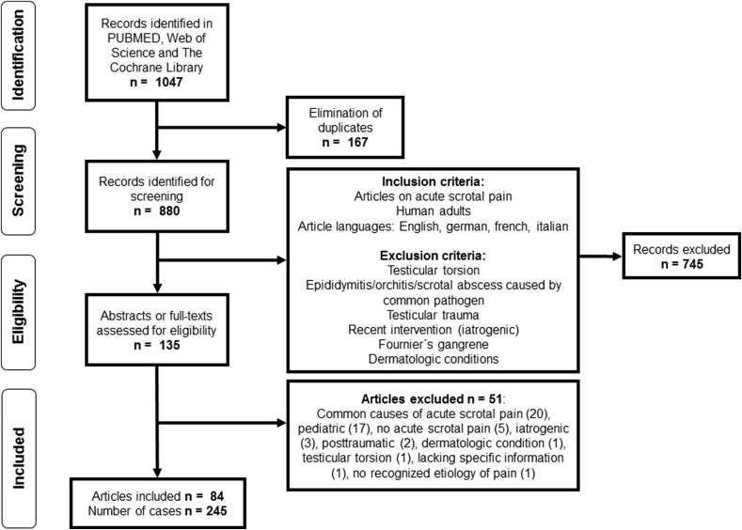

Results:
84 articles out of 1047 articles were selected and these following were identified as rare cause of acute scrotal pain: tumors, segmental testicular infarction, testicular vasculitis, acute pancreatitis, brucellosis, spermatic vein thrombosis, acute aortic syndrome, appendicitis, tuberculosis and filariasis

Tumor: Testicular mass usually present as painless but tumor infarction, necrosis and space-occupying growth, atrial bleed, and hematoma are sources of acute scrotal pain. Sometimes, epididymo-orchitis can mask the embryonal carcinoma which can delay the orchiectomy; it seems crucial to consider tumors as differential diagnoses of acute scrotal pain.

Brucellosis is a systemic, bacterial zoonosis that has been described to involve testicles, epididymis, seminal vesicles and prostate in 2–20%

Acute scrotal pain as a manifestation of acute pancreatitis is caused by retroperitoneal pancreatic fluid descensus.

Scrotal pain in acute aortic syndrome is likely the result of compression of the ilioinguinal/genitofemoral nerve by aortic aneurysma/retroperitoneal hematoma, also described as “referred” pain, acting at a site distant from the actual disease

Differential diagnoses after exclusion of the most common causes of acute scrotal pain and diagnostic and treatment options as suggested by the literature

